**1.01 Title.** Recycling Ordinance for the Town of Silver Cliff

**1.02 Purpose.** The purpose of this ordinance is to promote recycling, composting, and resource recovery through the administration of an effective recycling program, as provided in s. 287.11, Wis. Stats., and Chapter NR 544, Wis. Administrative Code.

**1.03 Statutory Authority.** This ordinance is adopted as authorized under s. 287.09(3)(b), Wis. Stats.

**1.04 Abrogation and Greater Restrictions.** It is not intended by this ordinance to repeal, abrogate, annul, impair, or interfere with any existing rules, regulations, ordinances or permits previously adopted or issued pursuant to law. However, whenever this ordinance imposes greater restrictions, the provisions of this ordinance shall apply.

**1.05 Interpretation.** In their interpretation and application, the provisions of this ordinance shall be held to be the minimum requirements and shall not be deemed a limitation or repeal of any other power granted by the Wisconsin Statutes. Where any terms or requirements of this ordinance may be inconsistent or conflicting, the more restrictive requirements or interpretation shall apply. Where a provision of this ordinance is required by Wisconsin Statutes, or by a standard in Chapter NR 544, Wis. Administrative Code, and where the ordinance provision is unclear, the provision shall be interpreted in light of the Wisconsin Statutes and the Chapter NR 544 standards in effect on the date of the adoption of this ordinance, or in effect on the date of the most recent text amendment to this ordinance.

**1.06 Severability.** Should any portion of this ordinance be declared unconstitutional or invalid by a court of competent jurisdiction, the remainder of this ordinance shall not be affected.

**1.07 Applicability.** The requirements of this ordinance apply to all residents and property owners generating postconsumer waste and recyclables within the Town of Silver Cliff.

**1.08 Administration.** The provisions of this ordinance shall be administered by the Silver Cliff Town Board or its designee.

**1.09 Effective Date.** The provisions of this ordinance shall take effect upon adoption by the Town Board of Silver Cliff and publication as required by law.

**1.10 Definitions.** For the purpose of this ordinance: 1) "Bi-metal container" means a container for carbonated or malt beverages, that is made primarily of a combination of steel and aluminum.

1. "Container board" means corrugated paperboard used in the manufacture of shipping containers and related products.
2. "Foam polystyrene packaging" means packaging made primarily from foam polystyrene that satisfies one of the following criteria:
   1. Is designed for serving food or beverages.
   2. Consists of loose particles intended to fill space and cushion the packaged article in a shipping container.
   3. Consists of rigid materials shaped to hold and cushion the packaged article in a shipping container.
3. "Glass Container" means a glass bottle, jar or other packaging container used to contain a product that is the subject of a retail sale and does not include ceramic cups, dishes, oven ware, plate glass, safety and window glass, heat resistant glass such as pyrex, lead based glass such as crystal, or TV tubes.
4. "HDPE" means high density polyethylene, labeled by the SPI code # 2.
5. "LDPE" means low density polyethylene, labeled by the SPI code # 4.
6. "Magazines" means magazines and other materials printed on similar paper.
7. "Major appliance" means a residential or commercial air conditioner, clothes dryer, clothes washer, dishwasher, freezer, microwave oven, oven, refrigerator, furnace, boiler, dehumidifier, water heater or stove.
8. "Multiple-family dwelling" means a property containing 5 or more residential units, including those which are occupied seasonally.
9. "Newspaper" means a newspaper and other materials printed on newsprint.
10. "Non-residential facilities and properties" means commercial, retail, industrial, institutional and government facilities and properties. This term does not include multiple family dwellings.
11. "Office paper" means high grade printing and writing papers from offices in non-residential facilities and properties. Printed white ledger and computer printout are examples of office paper generally accepted as high grade. This term does not include industrial process waste.
12. "Other resins or multiple resins" mean plastic resins labeled by the SPI code # 7.
13. "Person" includes any individual, corporation, partnership, association, local government unit, as defined in s. 66.0131 (l)(a), Wis. Stats., state agency or authority or federal agency.
14. "PETE" or "PET" means polyethylene terephthalate, labeled by the SPI code # 1.
15. "Plastic container" means an individual, separate, rigid plastic bottle, can, jar or carton, except for a blister pack, that is originally used to contain a product that is the subject of a retail sale.
16. "Postconsumer waste" means solid waste other than solid waste generated in the production of goods, hazardous waste, as defined in s. 291.01 (7) Wis. Stats. , waste from construction and demolition of structures, scrap automobiles, or high-volume industrial waste, as defined in s. 289.010 Wis. Stats.

1 8) "PP" means polypropylene, labeled by the SPI code # 5.

1. "PS" means polystyrene, labeled by the SPI code # 6.
2. "PVC" means polyvinyl chloride, labeled by the SPI code # 3.
3. "Recyclable materials" includes lead acid batteries; major appliances; waste oil; yard waste; aluminum containers; corrugated paper or other container board; foam polystyrene packaging; glass containers; magazines; newspaper; office paper; rigid plastic containers, including those made of PETE, HDPE, PVC, LDPE, PP, PS and other resins or multiple resins; steel containers; waste tires; and bi-metal containers.
4. "Solid waste" has the meaning specified in s. 289.01 (33), Wis. Stats.
5. "Solid waste facility" has the meaning specified in s. 289.01 (35), Wis. Stats.
6. "Solid waste treatment" means any method, technique or process which is designed to change the physical, chemical or biological character or composition of solid waste. "Treatment" includes incineration.
7. "Waste tire" means a tire that is no longer suitable for its original purpose because of wear, damage or defect.
8. "Yard waste" means leaves, grass clippings, yard and garden debris and brush, including clean woody vegetative material no greater than 6 inches in diameter. This term does not include stumps, roots or shrubs with intact root balls.

**1.11 Separation of Recyclable Materials.** Occupants of single family and 2 to 4 unit residences, multiple-family dwellings and non-residential facilities and properties shall separate the following materials from postconsumer waste: 1) Lead acid batteries

1. Major appliances
2. Waste oil
3. Yard waste
4. Aluminum containers
5. Bi-metal containers
6. Corrugated paper or other container board
7. Foam polystyrene packaging
8. Glass containers
9. Magazines

1 1 ) Newspaper

1. Office paper
2. Rigid plastic containers made of PETE, HDPE, PVC, LDPE, PP, ps, and other resins or multiple resins
3. Steel containers
4. Waste tires

**1.12 Separation Requirements Exempted.** The separation requirements of s. 1.11 do not apply to the following:

l) Occupants of single family and 2 to 4 unit residences, multiple-family dwellings and nonresidential facilities and properties that send their postconsumer waste to a processing facility licensed by the Wisconsin Department of Natural Resources that recovers the materials specified in s. 1.11 from solid waste in as pure a form as is technically feasible.

1. Solid waste which is burned as a supplement fuel at a facility if less than 30 % of the heat input to the facility is derived from the solid waste burned as supplement fuel.
2. A recyclable material specified in s. 1.1 (5) through (15) for which a variance has been granted by the Department of Natural Resources under s. 287.11 (2m), Wis. Stats., or s. NR 544.14, Wis. Administrative Code.

**1.13 Care of Separated Recyclable Materials.** To the greatest extent practicable, the recyclable materials separated in accordance with s. 1.11 shall be clean and kept free of contaminants such as food or product residue, oil or grease, or other non-recyclable materials, including but not limited to household hazardous waste, medical waste, and agricultural chemical containers. Recyclable materials shall be stored in a manner which protects them from wind, rain, and other inclement weather conditions. Attendants shall reject unseparated and/or contaminated recyclable material and direct such waste for disposal at MAR-OCO landfill.

* 1. **Management of Lead Acid Batteries, Major Appliances, Waste Oil and Yard Waste.** Occupants of single family and 2 to 4 unit residences, multiple-family dwellings and nonresidential facilities and properties shall manage lead acid batteries, major appliances, waste oil, and yard waste as follows:

1. Lead acid batteries are the responsibility of the property owner and are not accepted at the Silver Cliff Recycling Facility. They may be disposed of at MAR-OCO Landfill.
2. Major appliances shall be brought to the Silver Cliff Recycling Facility.
3. Waste oil is the responsibility of the property owner and is not accepted at the Silver Cliff Recycling Facility. This may be disposed of at MAR-OCO Landfill.
4. Yard waste is the responsibility of the property owner and is not accepted at the Silver Cliff Recycling Facility. This may be disposed of at MAR-OCO Landfill.

**1.15 Collection of Recyclable Materials.**

A. Except as otherwise directed by the Town of Silver Cliff, occupants of single family and 2 to 4 unit residences shall collect and transport to the Silver Cliff Recycling Facility the following materials specified in s. 1.11 (5) through (15) for the purpose of being recycled in a single stream format utilizing a selected private carrier:

1. Aluminum containers
2. Bi-metal containers
3. Corrugated paper or other container board
4. Glass containers
5. Magazines
6. Newspaper
7. Office paper
8. Plastic containers made of PETE
9. Plastic containers made of HDPE
10. Steel containers shall be collected and transported to the Silver Cliff Recycling Facility but shall not be commingled with other recyclable materials.
11. Waste tires are the responsibility of the property owner and are not accepted at the Silver Cliff Recycling Facility. They may be disposed of at MAR-OCO Landfill.
12. The following items are exempted from recycling laws at this time under a State variance and may be discarded with postconsumer (household) waste: 1) Foam polystyrene packaging

2) Plastic containers made of PVC 3) Plastic containers made of LDPE

1. Plastic containers made of PP
2. Plastic containers made of PS
3. Plastic containers made of other resins or multiple resins

**1.16 Responsibilities of Owners or Designated Agents of Multiple-Family Dwellings.**

1. Owners or designated agents of multiple-family dwellings shall do all of the following to recycle the materials specified in s. 1.11 (5) through (15):
   * 1. Provide adequate, separate containers for the recyclable materials.
     2. Notify tenants in writing at the time of renting or leasing the dwelling and at least semiannually thereafter about the established recycling program.
     3. Provide for the collection of the materials separated from the solid waste by the tenants and the delivery of the materials to a recycling facility.
     4. Notify tenants of reasons to reduce and recycle solid waste, which materials are collected, how to prepare the materials in order to meet the processing requirements, collection methods or sites, locations and hours of operation, and a contact person or company, including a name, address and telephone number.
2. The requirements specified in l) do not apply to the owners or designated agents of multiplefamily dwellings if the postconsumer waste generated within the dwelling is treated at a processing facility licensed by the Department of Natural Resources that recovers for recycling the materials specified in s. 1.11 (5) through (15) from solid waste in as pure a form as is technically feasible.

**1.17 Responsibilities of Owners or Designated Agents of Non-Residential Facilities and Properties.**

1. Owners or designated agents of non-residential facilities and properties shall do all of the following to recycle the materials specified in s. 1.11 (5) through (15):
   * 1. Provide adequate, separate containers for the recyclable materials.
     2. Noti%/ in writing, at least semi-annually, all users, tenants and occupants of the properties about the established recycling prop-am.
     3. Provide for the collection of the materials separated from the solid waste by the users, tenants and occupants and the delivery of the materials to a recycling facility.
     4. Notify users, tenants and occupants of reasons to reduce and recycle, which materials are collected, how to prepare materials in order to meet the processing requirements, collection methods or sites, locations and hours of operation, and a contact person or company, including a name, address and telephone number.
2. The requirements specified in 1) do not apply to the owners or designated agents of nonresidential facilities and properties if the postconsumer waste generated within the facility or property is treated at a processing facility licensed by the Department of Natural Resources that recovers for recycling the materials specified in s. 1.11 (5) through (15) from solid waste in as pure a form as is technically feasible.
   1. **Prohibitions on Disposal of Recyclable Materials Separated for Recycling.** No person may dispose of in a solid waste disposal facility or burn in a solid waste treatment facility any of the materials specified in s. 1.11 (5) through (15) which have been separated for recycling, except waste tires may be burned with energy recovery in a solid waste treatment facility.
   2. **Enforcement.**
3. For the purpose of ascertaining compliance with the provisions of this ordinance, first refer to the Town of Silver Cliff Recycling Compliance Assurance Plan.
4. Any authorized officer, employee or representative of Advanced Disposal, JNS Enterprises, GAD, and the Town of Silver Cliff may inspect recyclable materials separated for recycling, postconsumer waste intended for disposal, recycling collection sites and facilities, collection vehicles, collection areas of multiple-family dwellings and non-residential facilities and properties, and any records relating to recycling activities, which shall be kept confidential when necessary to protect proprietary information. No person may refuse access to any authorized officer, employee or authorized representative of the Town of Silver Cliff who requests access for purposes of inspection, and who presents appropriate credentials. No person may obstruct, hamper, or interfere with such an inspection.
5. Any person who violates a provision of this ordinance may be issued a citation by the Silver Cliff Constable or Silver Cliff Town Board to collect forfeitures. The issuance of a citation shall not preclude proceeding under any other ordinance or law relating to the same or any other matter. Proceeding under any other ordinance or law relating to the same or any other matter shall not preclude the issuance of a citation under this paragraph.

4) Penalties for violating this ordinance may be assessed in an amount to be determined by the Silver Cliff Town Board.

2025 by the Town Board of the Town of

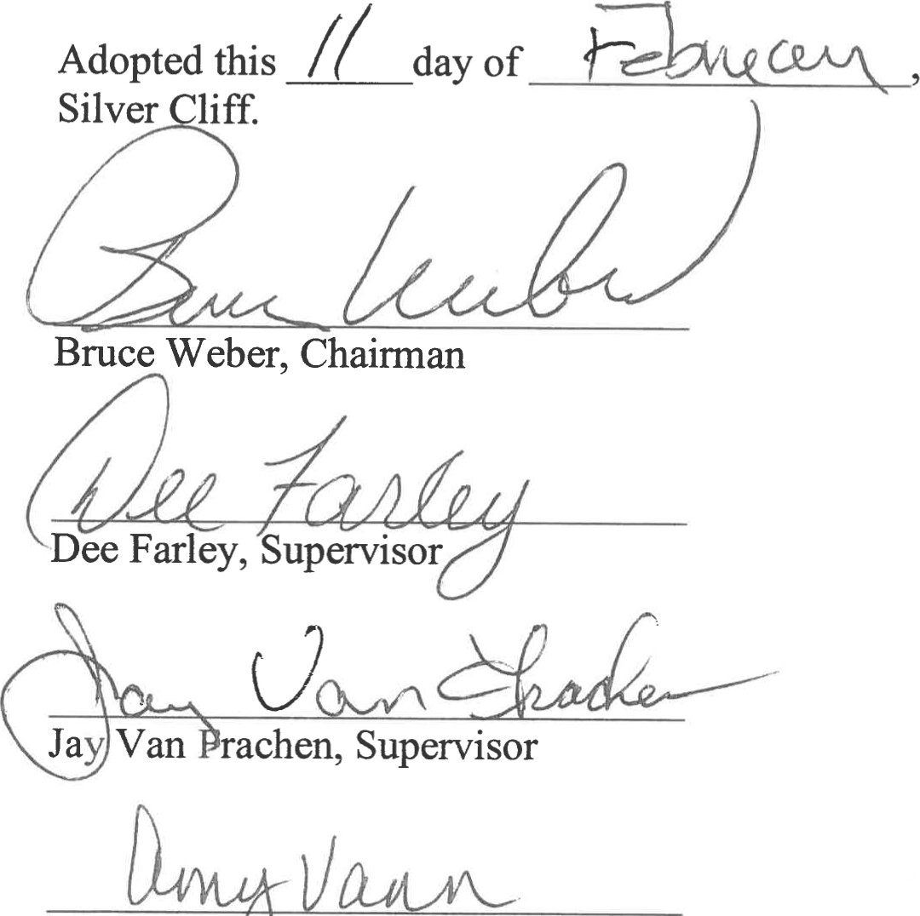

Amy

Vannieuwenhoven,

Clerk