Everyone is invited to the
3rd annual
Silver Cliff Christmas Concert
Saturday, Dec. 30
3pm at the Town Hall
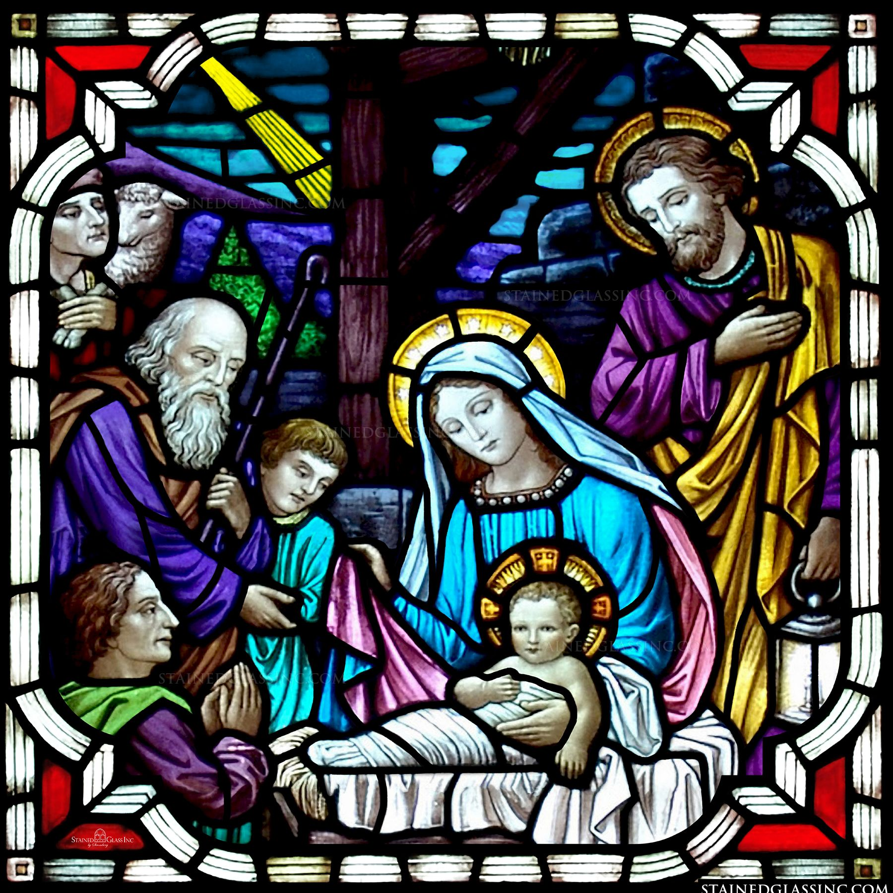
featuring the Kanzenbach family singers

Admission for this family event is a smile! There will be a
free-will donation collection for anyone wanting to contribute
to our new fire and rescue building.
May God bless us all with a merry Christmas and a happy and healthy 2024!

